Date:23/01/2026
8.Create a Virtual Hard Disk and allocate the storage using virtual box.

AIM:
SOFTWARE USED
- Oracle VM VirtualBox – Used to create and manage the virtual machine, virtual hard disk (VDI), and storage allocation.
- Host Operating System – Windows / Linux (installed on the physical machine).
- Guest Operating System (ISO file) – Ubuntu Linux / Windows (used for VM installation)

PROCEDURE:

- Download and install Oracle VM VirtualBox on the host system.
- Open VirtualBox and click on New to create a new virtual machine.
- Enter the name of the virtual machine and select the type and version of the operating system.
- Click Next and allocate the required RAM size for the virtual machine.
- In the Hard Disk section, select Create a virtual hard disk now and click Create.
- Choose the hard disk file type as VDI (VirtualBox Disk Image) and click Next.
- Select the storage allocation type as Dynamically allocated or Fixed size.
- Specify the size of the virtual hard disk (for example: 20 GB) and click Create.
- The virtual hard disk is now created and attached to the virtual machine.
- Select the virtual machine and click Start to verify the disk allocation.

Output

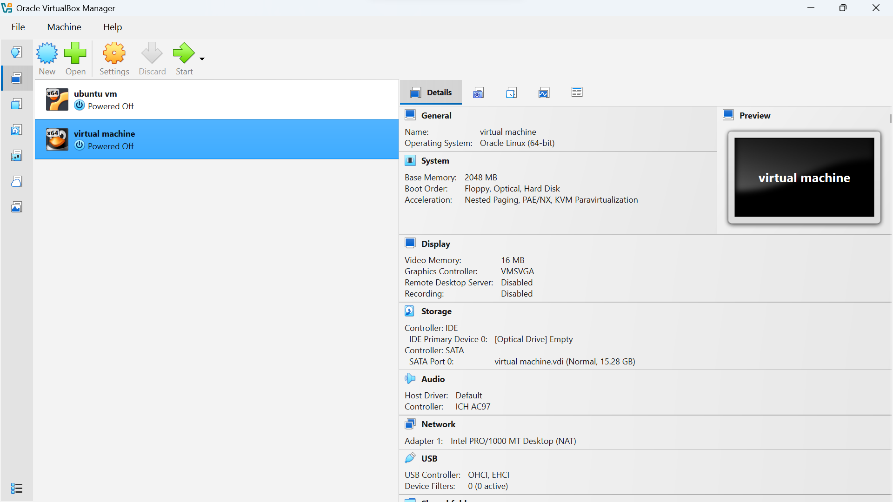

RESULT:
The virtual hard disk was successfully created and storage was allocated using Oracle VM VirtualBox. The virtual machine was configured correctly, and the allocated virtual hard disk was attached and ready for operating system installation and use.

